**Course Project - BIA 600**

**Descriptive and Statistical Analysis of a Sales Dataset**

***Guided by Dr. Bei Yan***

**Team 2:**

Dhruv Kotecha – 10468578

Dishank Sanklecha – 20007615

Rani Ramrakhiani - 10477664

Varun Chinchalkar - 10477664

**Introduction:**

The retail industry is highly competitive, with only some barriers to entry. Each Company competes with other local, regional, and national retailers for customers, merchandise, services, and other important aspects of the Company’s business.

Competitive analysis is an integral part of developing an organization’s strategy. It is done by identifying, then evaluating strategies for strengths and weaknesses.

Roger Ferro, the Country head of a multi-national retail company is responsible for understanding the sales numbers and to make them grow. Company needs to come up with a strong retail marketing strategy to stay ahead in business. For this, he wants to gauge and execute suitable sales techniques, to scale up the sales numbers for various products, retailed by various vendors.

Strategic vendor management is an essential part of any profitable business. A well-executed vendor management program will control vendors’ sourcing and researching, quality control, obtaining quotes, turnaround times, contracts, performance evaluation, and more.

The country heads want to evaluate the stock, price, number of items sold and quality rating for various categories to find the sales trends. He would also want to evaluate the inventory status for various categories, subcategories, and items.

With such meticulous exploration of vendor sales and inventory stocks, the country head can formulate schemes to improvise sales in low profit periods and confirm that the inventory has enough stock to meet the customer requirements.

**Dataset Explanation:**

Our dataset summarizes information about the large retail company Electcom Inc, specializing in retail of multi purpose products. The time-period of the data collected from the company is from 2010-2012.

This data set is sourced from Kaggle which contains 1342 Rows and 15 Columns. The Tools and Techniques used for analyzing the data are Excel, Tableau, and Statistical Analysis. We sampled information from the two different public datasets listed below to create one and we used joints to do join two data sets.

The On Order and EOH represents the inventory to be delivered and current inventory of each vendor and the counts of the products they have used.

Our final dataset contained the below seven variables. These variables each were important to answering our questions about vendor sales and inventory stocks, the country head can formulate proposals to improvise sales in low profit periods and confirm that the inventory has enough stock to meet the customer requirements.

Visualization – 1

**Day** – Day column is measured by Interval scale such as “01-Jan-10” This field holds the date of orders delivered from 2010-2012. Where there is order and the difference between two values is meaningful.

**Price** – Price column is measured by Ratio such as “457”. This field holds the prices of all the items and this field helped in knowing at what rate vendors are selling their items. Helps the manager to analyze if the pricing will meet the budget of the organization and will be able to gain profits.

**Delivery Accuracy** - Delivery Accuracy is measured by Discrete measurement scale such as “On Time” which depicts difference between the delivery types helps us to analyze the delivery standards follow and if the items were delivered timely.

**Quality Rating** – Quality rating is measured by ordinal measurement scale where the field can be ordered or ranked according to some relationship to one another. Where the minimum value is 70 and the highest is 99. This helps us to gauge the quality of the products which were delivered if they were of the satisfactory quality standards.

**Vendor Name** – Vendor name is measured by categorical scale and this field does not have a specific order to follow and it specifies the name of the vendor. This will help us in knowing which is the reliable vendor who delivers the products on time and maintains quality standards and has stock available of the items. Example such as Indiewealth Corp

**Sub-category**- Sub-category is a categorical measurement scale which specifies the name of the subcategory items such as “smart phone” and we can analyze which items are delivered on time.

Revenue from Sold and EOH is measured by Ratio scale this covers calculations by the product of price and the order of items sold (100*20) = 2000 and value is depicted on our data set as 155760

Percentage of delivery accuracy



* From the following analysis done through pivots we understand percentage of delivery accuracy which is been obtained from each of the vendor
* This will help the country head to understand which vendor is performing better in deliveries of their goods
* The parameters taken for deliveries are taken over of a year. Parameters are Early delivery, on-time delivery and late deliveries
* From the data we understand that Indiewealth Corp – 217 on early delivery, 126 on-time delivery, Highland Pvt Ltd- 142 on early delivery by count.
* Indiewealth Corp –34.08%, Highland Pvt Ltd – 21.63% of Delivery Accuracy
* From this we can deduce that Indiewealth is a suitable vendor in delivery accuracy scenario

|  |  |  |  |  |  |
| --- | --- | --- | --- | --- | --- |
| Delivery Accuracy | Earthworks Pvt.Ltd | Highland Pvt.Ltd | Hugh Woods | Indiewealth Corp | Naugles Corp.Ltd |
| Early Delivery | 81 | 142 | 4 | 217 | 129 |
| Late Delivery | 70 | 59 | 45 | 114 | 89 |
| On Time Delivery | 118 | 89 | 24 | 126 | 34 |

Analysis is been distributed according to the three parameters taken into consideration.

Vendor quality rating

* To identify the quality rating of a vendor, we need to first take into consideration of customer ratings and their feedback for each vendor to find how satisfied were the customers with each individual vendor.
* To identify this, we have taken an average of all vendor quality ratings taken from all the customers.
* We can here deduce that Indieweath Corp has a quality rating of 34.17% which is highest compared to the others hence making it insightful to know the better-quality vendor out of the list.

|  |  |
| --- | --- |
| Vendor Name | Avg of Quality_Rating |
| Earthworks Pvt.Ltd | 20.00% |
| Highland Pvt.Ltd | 21.63% |
| Hugh Woods Designers | 5.44% |
| Indiewealth Corp | 34.17% |
| Naugles Corp.Ltd | 18.76% |

**Analytics with Inferential Statistical Tools:**

Before beginning the analytical approach with inferential statistical tools, we had to rethink our questions to align with the dataset. In its most basic form, the question we asked ourselves was: is the vendor's quality and delivery accuracy sufficient to meet the needs of the customers, and which vendor will provide profits? To find an answer to this question, we ran a number of tests from the data analytics pack in Excel and looked for patterns.

This correlation relates two subcategories of the product, which is offered by four vendors. In this hypothesis, we compared the prices of two subcategories that were sold over a period of time. Raw data revealed that the juices were more expensive and sold by the vendors more frequently. We performed a t-Test on a single column, namely price. After checking the one tail values of the t Stats and the critical value, we concluded that the price of Tea and Coffee was greater than Juice, thus rejecting the Null Hypothesis. Thus, we learned from this test that the customers preferred Coffee and Tea more even though the prices were high for the product. For the vendors, it was important to increase the quantity of the product to satisfy customer demand.

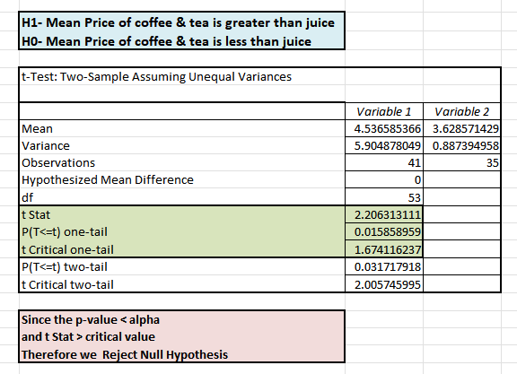

The following correlation compares the two vendors; based on the previous analysis of the Quality Ratings and Delivery Accuracy, we were able to identify the best two vendors who performed well during the time period specified in the data set. The comparison would help us answer our question about which vendor should be more profitable and help satisfy the customers' needs while also providing a profit.

To begin, we used Data Visualization to compare a product sold by two vendors, in this case, Smartphones. In the visualization, we counted the number of products sold by each vendor as well as their average price per product. Using this, we deduced that Indiewealth Corp had a greater number of products and a higher average price. To see if our prediction was correct, we conducted a Hypothesis test.

Visualization - 2

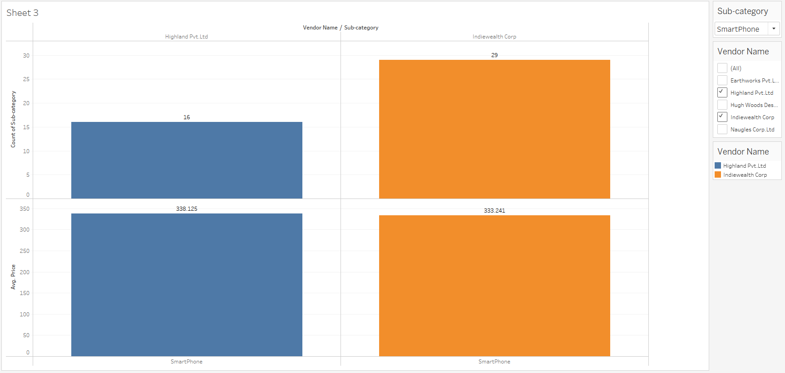

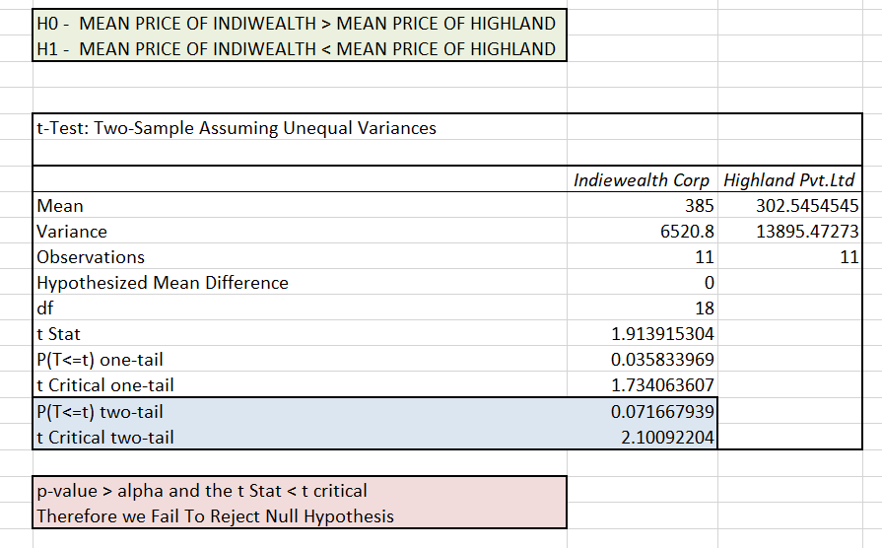

The hypothesis test we used was the Upper One Tail t-Test, and we compared the prices of smartphones from two vendors over the course of the period. We discovered that the p-value was greater than alpha and the t stats < critical value, causing us to fail to reject the null hypothesis. As a result, we could conclude that, while Indiewealth's price was higher than Highland's, Indiewealth was the best vendor when other factors were considered.

**Conclusion:**

As we have performed all the test those are Quality rating, On time delivery, T-test, Anova analysis.

As per those analysis performed, we can conclude that there are two best vendors i.e Indieweath Corp and Highland Pvt Ltd with their delivery accuracy along with order counts taken from an average of 3 years from 2010-2012.

Even though the price of Indieweath Corp is greater but the quality and delivery time is better than Highland Pvt Ltd. Roger Ferro can consider these parameters while evaluating vendors and resulting in higher sales number and cascading into larger revenue numbers and finalize on choosing Indieweath Corp as a better vendor over others. As vendor is critical to the success of the company. They drive new growth within your industry and ensure your able to attain revenue and profit goals. They are at the heart of many of the organization’s developments and activities.

END OF THE DOCUMENT